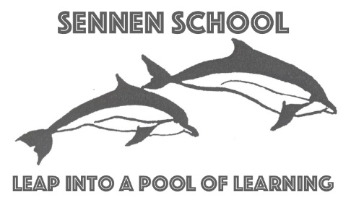
SENNEN SCHOOL
Sennen, Penzance, Cornwall TR19 7AW
Tel/Fax: 01736 871392
Headteacher: Mrs N Smith
e-mail: secretary@sennen.cornwall.sch.uk

Dear Parent or Carer,
School Closure from Friday 20th March 2020
In line with the recent Government announcements, all schools will be closing from the end of the school day on Friday 20th March.
Also in line with the Government expectations, children of key workers and vulnerable pupils will be able to attend an educational setting. In order to allow us to plan suitable provision for these children, Sennen School will be closed for to all pupils on Monday 23rd March and Tuesday 24th March.
We are expecting to have provision in place for the children of key workers and vulnerable pupils from Wednesday 25th March.
We will be applying the Government guidance on the definition of Key Worker roles (see overleaf).
Please read the criteria on the next page regarding key workers and get in touch with the school via email today or over the weekend explaining your circumstances and needs. If eligible, you will be contacted individually with the details of the provision for your child/children by 5pm Tuesday but we will try to get this information to you as early as possible.
We will use text messages and emails to keep you updated on this evolving situation.
All parents/carers, please be aware that if we do not contact you on Monday or Tuesday next week, then your children will be expected to stay at home in your care.
Thank you for your support and understanding at this challenging time.

Yours faithfully,
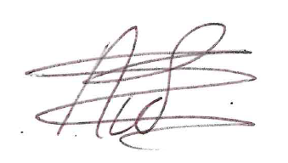
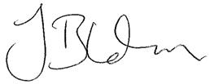
Dr J Blunden OBE and Nichola Smith
Chief Executive Headteacher
Truro and Penwith Academy Trust Nichola Smith

Key worker guidelines:
Even if you are a Key Worker please be aware that the Government are advising that children should still stay at home if safe, but school will remain open if they ‘absolutely need to attend’.
The Government have released these key principles:
1. If it is at all possible for children to be at home, then they should be.
2. If a child needs specialist support, is vulnerable or has a parent who is a critical worker, then educational provision will be available for them.
3. Parents should not rely for childcare upon those who are advised to be in the stringent social distancing category such as grandparents, friends, or family members with underlying conditions.
4. Parents should also do everything they can to ensure children are not mixing socially in a way which can continue to spread the virus. They should observe the same social distancing principles as adults.
5. Residential special schools, boarding schools and special settings continue to care for children wherever possible.

Key Workers include:
Health and social care
This includes but is not limited to doctors, nurses, midwives, paramedics, social workers, care workers, and other frontline health and social care staff including volunteers; the support and specialist staff required to maintain the UK’s health and social care sector; those working as part of the health and social care supply chain, including producers and distributers of medicines and medical and personal protective equipment.
Education and childcare
This includes nursery and teaching staff, social workers and those specialist education professionals who must remain active during the COVID-19 response to deliver this approach.
Key public services
This includes those essential to the running of the justice system, religious staff, charities and workers delivering key frontline services, those responsible for the management of the deceased, and journalists and broadcasters who are providing public service broadcasting.
Local and national government
This only includes those administrative occupations essential to the effective delivery of the COVID-19 response or delivering essential public services such as the payment of benefits, including in government agencies and arms’ length bodies.
Food and other necessary goods
This includes those involved in food production, processing, distribution, sale and delivery as well as those essential to the provision of other key goods (for example hygienic and veterinary medicines).
Public safety and national security
This includes police and support staff, Ministry of Defence civilians, contractor and armed forces personnel (those critical to the delivery of key defence and national security outputs and essential to the response to the COVID-19 pandemic), fire and rescue service employees (including support staff), National Crime Agency staff, those maintaining border security, prison and probation staff and other national security roles, including those overseas.
Transport
This includes those who will keep the air, water, road and rail passenger and freight transport modes operating during the COVID-19 response, including those working on transport systems through which supply chains pass.
Utilities, communication and financial services
This includes staff needed for essential financial services provision (including but not limited to workers in banks, building societies and financial market infrastructure), the oil, gas, electricity and water sectors (including sewerage), information technology and data infrastructure sector and primary industry supplies to continue during the COVID-19 response, as well as key staff working in the civil nuclear, chemicals, telecommunications (including but not limited to network operations, field engineering, call centre staff, IT and data infrastructure, 999 and 111 critical services), postal services and delivery, payments providers and waste disposal sectors.

