Family Games 1
Game / Activity | Resources needed
- Balloon Tennis  Work together to keep the balloon in the air by batting them with your hands. Add more balloons to make it more of a challenge! | Balloons
- I went shopping and I bought…  The first person says “I went shopping and I bought…” and they add one item eg sausages, ice-cream, soup. The next person says “I went shopping and I bought sausages and..” and they add their own idea. Continue with each person adding an item. See how long your list can be!  Other variations could be:-  - I went to the zoo and saw…  - I had a meal and ate…  - I went on holiday and took… | None
- Pirates Treasure  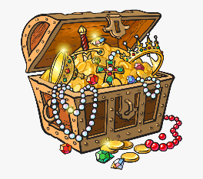  One person to stand at the end of the room/garden with their back to the other players. They are the pirate guarding the treasure! (have a selection of toys/objects just behind them). The other players start at the other end of the room/garden and have to creep up to try and steal a piece of treasure. The pirate can turn around at any point and if they catch anyone moving they must go back and start again. See how much treasure you can steal in 2/5/10 minutes! | Toys and household objects
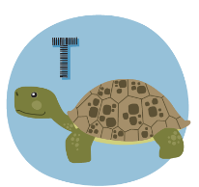  - Animal Alphabet  Take it in turns to name an animal beginning with each letter of the alphabet. | None
- Charades / Miming  Choose a theme and 1 at a time, mime something from that theme for the others to guess. Themes could include:-  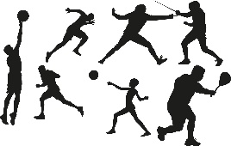  - Orchestra  - Sports  - Animals  - Jobs | None
- Beans  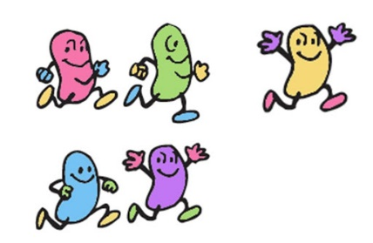  Choose one person to be the leader and call out the ‘beans’. Everybody else to do the actions. Take turns to be the leader.  - Jumping bean – jump  - Frozen bean – stand very still with arms by your side.  - Jelly bean – wobble like a jelly  - Baked bean – lay flat on the floor  - Runner bean – run on the spot or around the room/garden if you have space  - Chilli bean – shiver and shake  - Magic bean – pretend to wave a wand or wiggle your fingers as if casting a spell. | None
- Earth, Sea and Air  Choose one person to be the leader. They throw a ball (or beanbag/soft toy) to each person, one at a time, and say either earth, sea or air’. That person has to name a creature that lives in that environment or something you might see there. Move on to the next person and repeat. Take turns to be the leader. Try not to repeat an animal that has already been said! | Ball, beanbag or toy.

