How to login and use MyMaths

Type www.MyMaths.co.uk into google
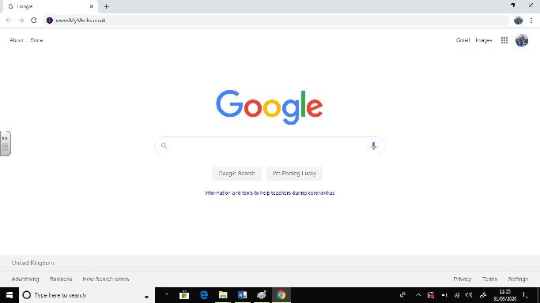

You will then be taken to this screen. Click Log in
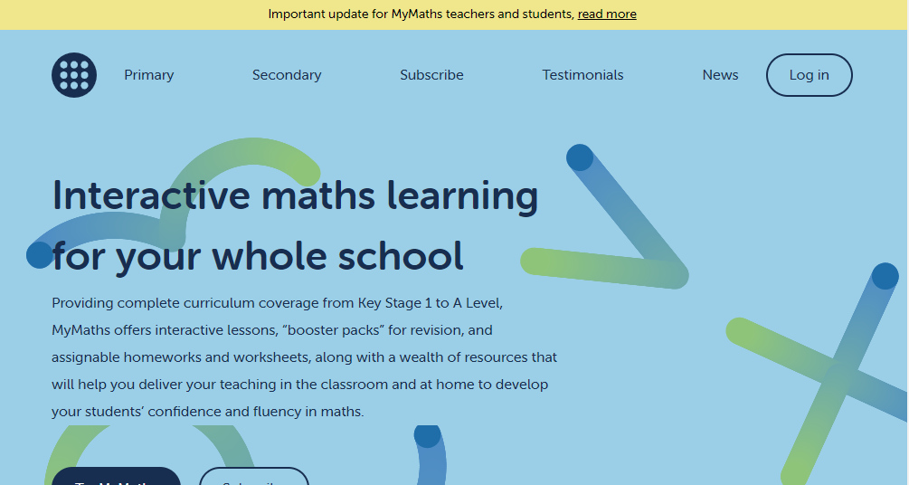

This page will then show up.
Type sennen into School username
School password is circle63
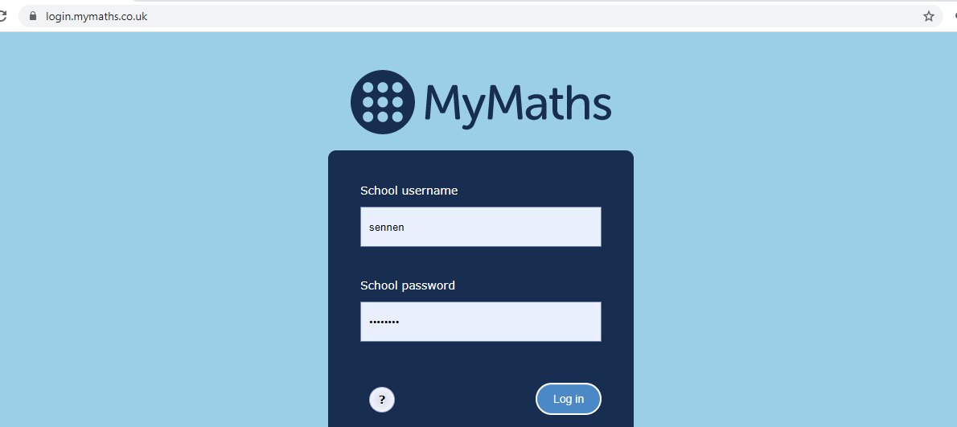
Then click Log in

Type in your portal username and password. The username is a 3 digit number and the password is 3 lower case letters (these will be sent in a separate document) I have used a made up account for the purpose of these instructions.
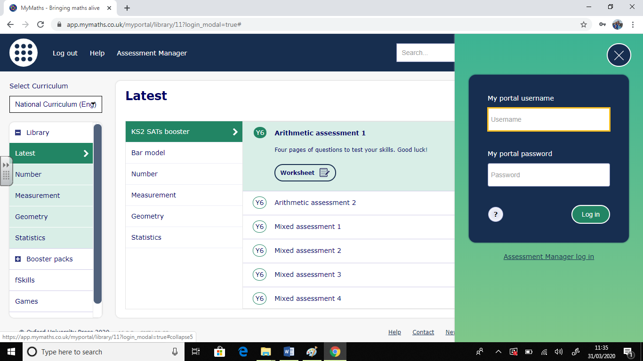
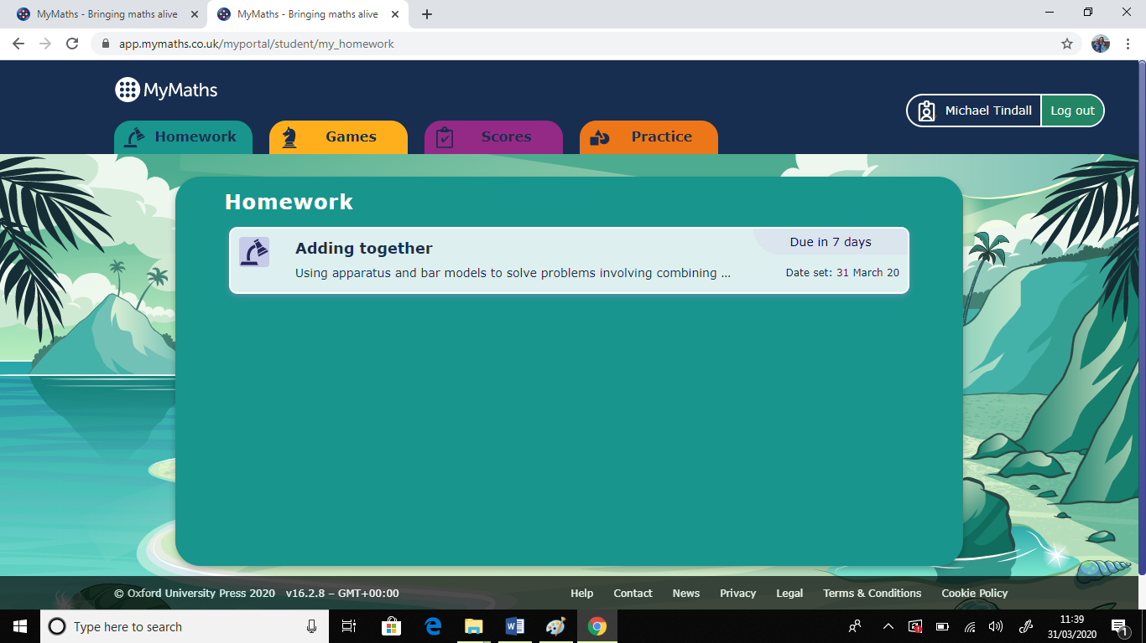
Any homework set is now visible. There are also games to play (have an explore)
Click on the homework

You will then have these 2 options. I suggest you ‘Try the lesson’ as the homework may have new concepts or you may need to refresh your memory.

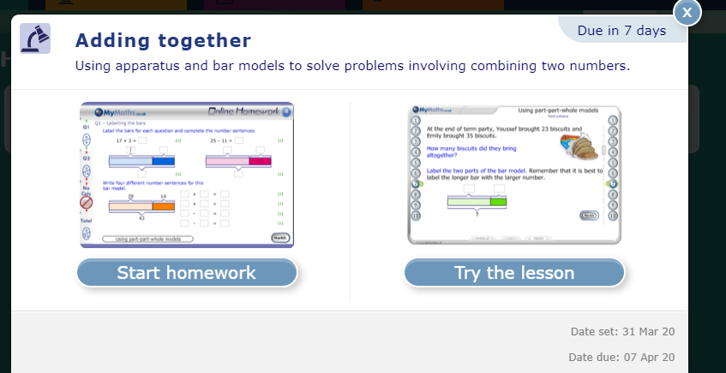
When you select Try the lesson you will see this screen:
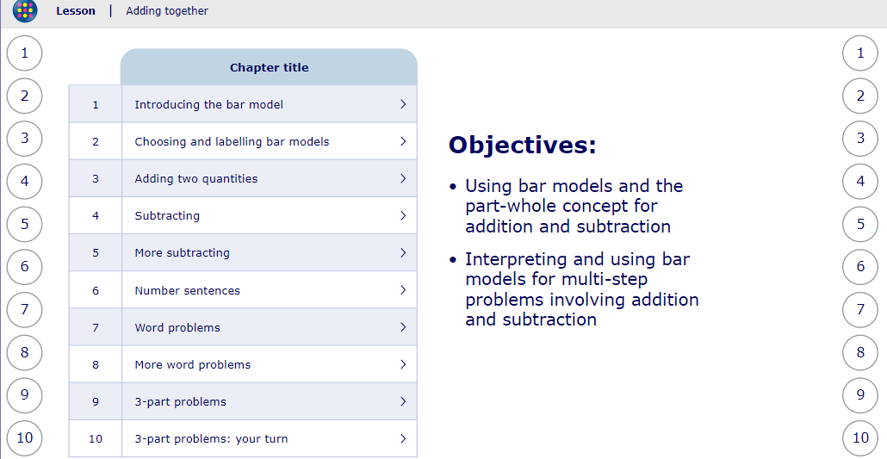

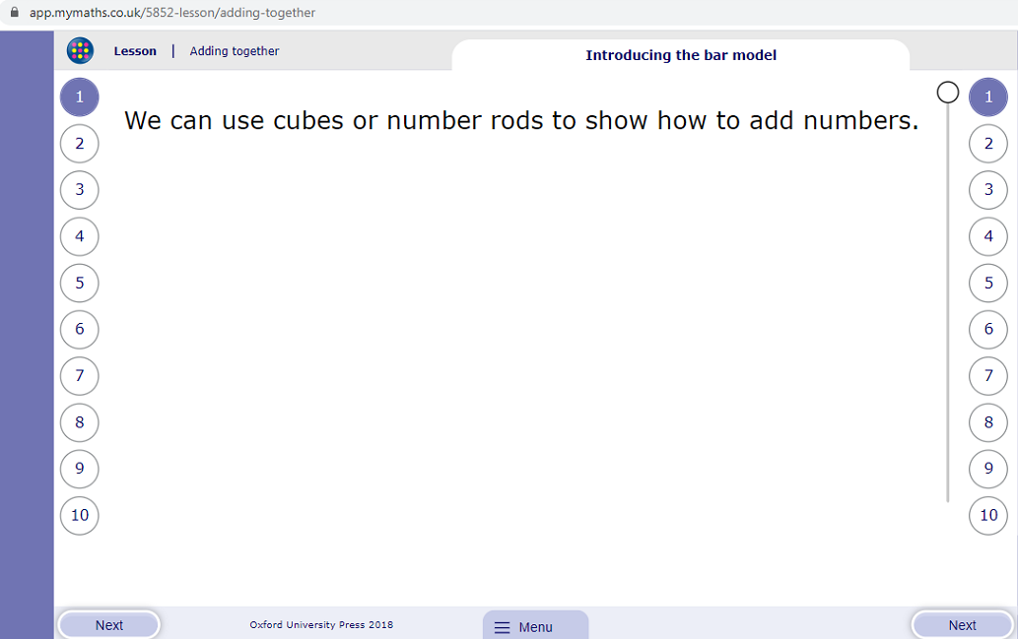
Work your way through the chapters. Make sure you press next at the bottom of the screen to go through all of it.

The menu bar allows you change the overlay (dyslexia friendly)
Once you have completed the lessons you can close down the tab and then select Start Homework (see above)
A screen like this one below will appear.
You must fill in all of the answers and then click ‘Mark it’
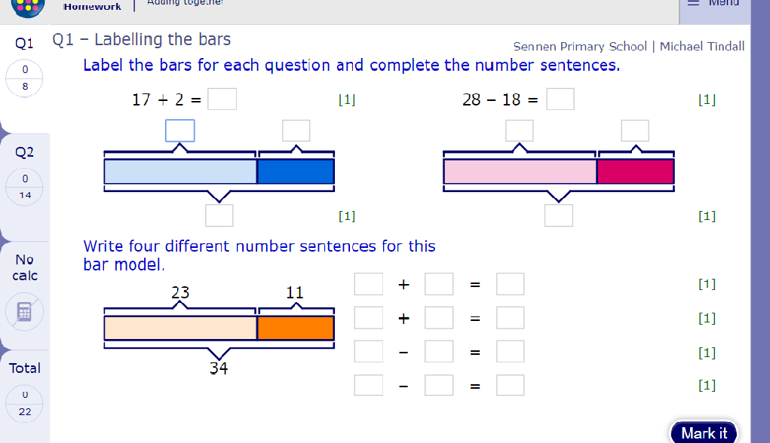

This then tells you if you got it right and where you went wrong.

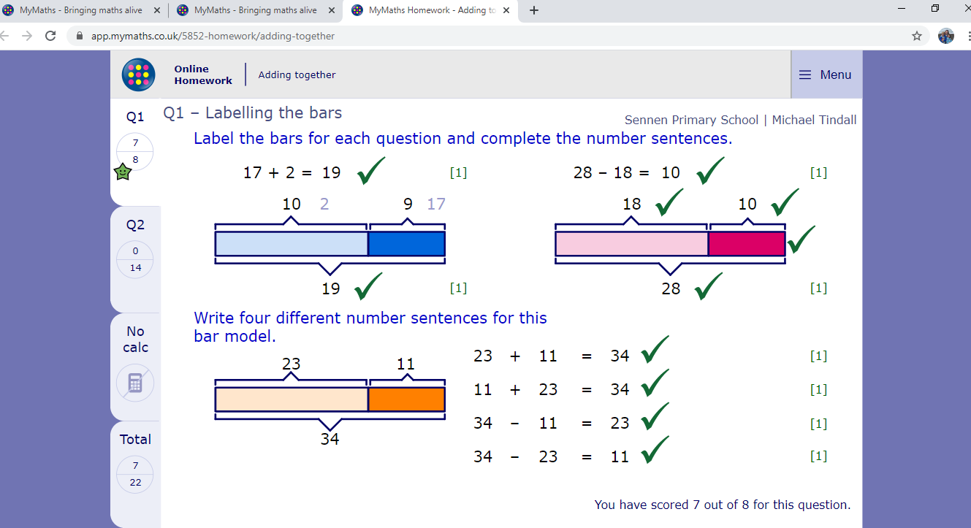
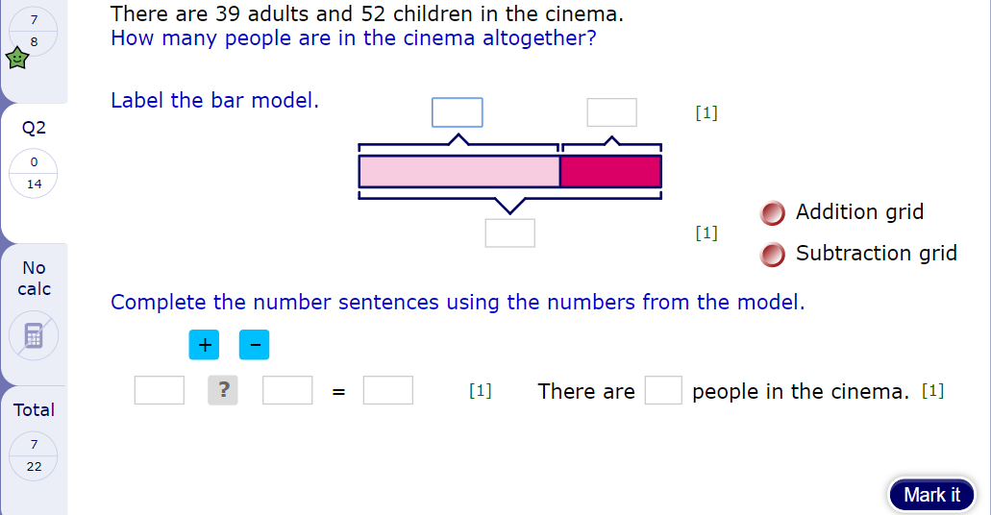
Then go to Q2 tab and complete the questions

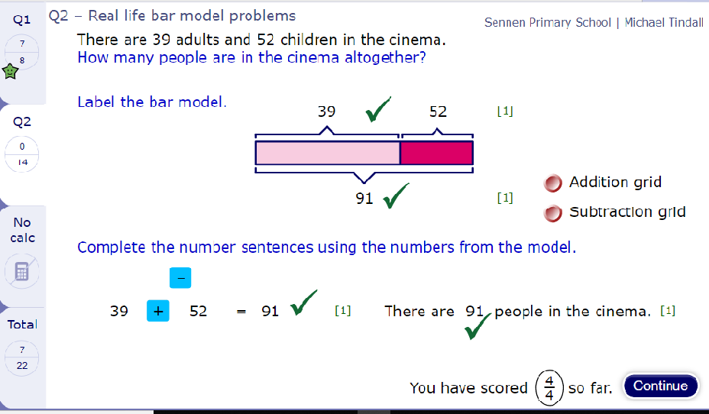

Press continue and work through the remaining questions.

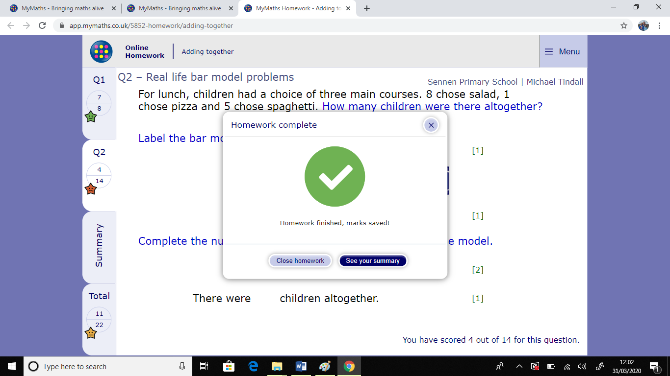
When you have finished this screen will pop up. You can close homework or see your summary. This then automatically updates on the teachers account.

If you look at your scores tab you can have a look and have another go!
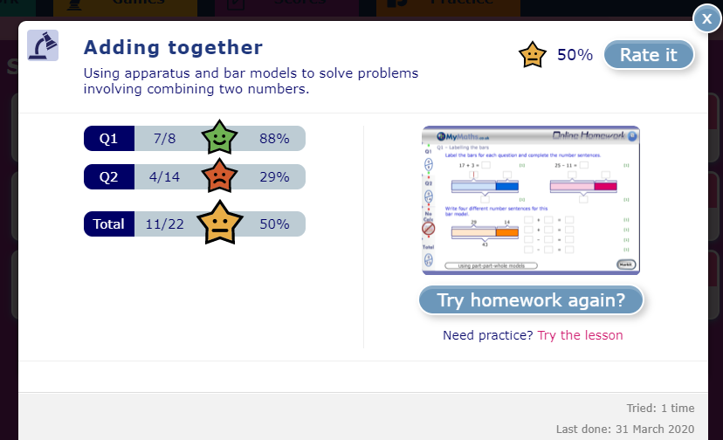

I hope this helps! Have fun!

