SENNEN SCHOOL

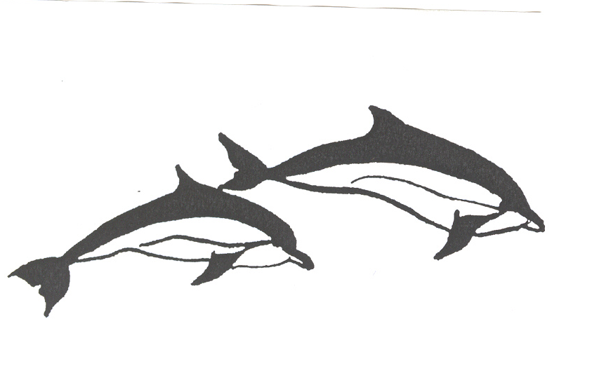
NEWSLETTER
Head Teacher: Nichola Smith
Contacts:
secretary@sennen.cornwall.sch.uk
Telephone: 01736 871392

Date: Friday 13th December 2019 Autumn Term Number 14

ATTENDANCE A.M: Aire 94%
Brisons 95%
Longships 85.5%
Cowloe 96.7%

NO LEARNING LEGENDS THIS WEEK.

AIRE CLASS – Firstly, congratulations to all the children for maintaining an enthusiastic attitude towards learning, even at the end of this very long term. All the staff have been delighted with the progress they have made, and it was lovely to share some of this with parents at the Open Morning this week. We hope to arrange more of a museum experience next term – please look for the homework sheet in your child’s bag for more details. Also, many thanks to the children for their wonderful performances on Wednesday, even when feeling tired or hurt – the show definitely went on! They looked lovely in the costumes provided by their parents, and we overcame the rather interesting weather conditions as well. Next term, information will be coming out to parents about the children’s new ‘next steps’, and what we are looking for by the end of each year group. Please don’t forget to keep recording those ‘wow’ moments on Tapestry, as they really round out the children’s Learning Journeys. Have a very happy Christmas everyone, from Aire Class staff. 13/12/19 AIRE LEARNING LEGEND was Millie for working so hard this term to learn her letter sounds and to sound out and blend them to read words: super learning attitude.

BRISONS AND LONGSHIPS CLASSES – It has been a busy week in Brisons, but lots of fun. The Christmas performance was super with the children displaying a variety of musical talents. It was lovely to see so many of you during our open morning to share in our learning. If any of you were unable to attend and would like to look at your child’s work, please come and let us know and we can arrange a suitable time. Have a lovely relaxing Christmas and we’ll look forward to seeing you all refreshed in January.
13/12/19 BRISONS LEARNING LEGEND was Alice for being really focused in Maths which is helping her to make good progress. Well done – keep this up! 13/12/19 LONGSHIPS LEARNING LEGEND was Gabriel. Gabriel is beginning to show more resilience in maths, thinking about what he has to do and being proud when he succeeds!
COWLOE CLASS – Wow! What a fantastic, yet busy couple of weeks we have had! It was great to see the children all dressed up for Victorian day. We learnt our tables by rote, said the Lord’s Prayer and took part in Drills (PE). The children were exceptionally behaved (nothing to do with the cane and Dunce’s cap!!) We also had fun learning about Irreversible Changes and baking our own sponge cakes. I would like to say how super proud I am of every single child in Cowloe class for their production of A Christmas Carol. They were absolutely brilliant – thank you to all the parents who helped them learn their lines and sorted out fabulous costumes! Finally, I would like to wish you all a fantastic Christmas and a Happy New Year! See you in 2020! 13/12/19 COWLOE LEARNING LEGEND was Liam. Liam has shown super focus and resilience despite all of the festive distractions. Well done!

The winning house last week is was Gwynver with 430 house points, Maen had 428 and Vellandreath 310. Anabelle had the most points for Gwynver, Elsie for Maen and for Vellandreath – well done everyone!

House points earned this week will be carried over into the New Year.

HEADTEACHER
What a wonderful term it has been! There has been so much learning going on across the school and the children have worked incredibly hard. Thank you to everyone who has helped at events and sent in cards and gifts, the whole staff are really appreciative. I would like to say a massive well done to all of the children for their very superb performances on Wednesday. They battled over to the hall in horrendous weather and did their absolute best, we were all so very proud. I would also like to say a big thank you to all the staff at school. They have gone over and above this term and everyone (children and adults alike) deserve a good rest.

Children are due back on Tuesday 7th, please remember PE kits as we will be starting our new PE programme on the Thursday. I would also like to ask that children bring a water bottle to school. We actively encourage them to drink and it is much easier if they can access water in class rather than queueing at the fountain.
I hope everyone has a very merry Christmas and a happy new year!

