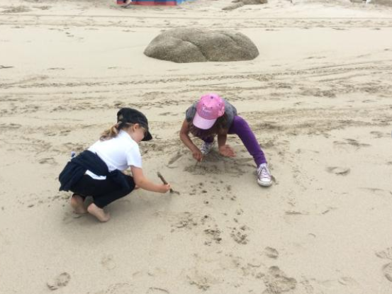

Sennen Beach School

Welcome to Sennen Beach School.
This is where the journey begins...... the sound of a bird calling overhead; the seagull looking for something tasty to eat. The big blue ocean is waving at us and the crabs are coming to say hello. The adventure, imaginations and experiences are about to start at the beach.
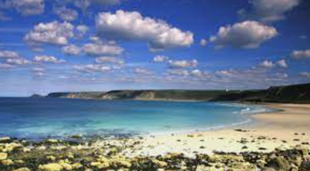

At Beach School the creativity, confidence and self-esteem of each explorer will start to grow and develop with every visit they make. The experiences and adventures that take place in Beach School will always be enjoyed and remembered.
Beach School adopts the same ethos to learning and understanding as Forest School. This holistic approach gives the children a chance to explore and investigate the marine environment right here in Sennen. The children will be using their imaginations, gross and fine motor skills as well as problem solving. Learning through touch and using all their senses they will enhance their knowledge and understanding of the world they live in and how to keep themselves and others safe when at the beach. The children will also learn about what we can do to maintain and respect this environment and ways to help keep the beach clean and safe.

What is Beach School?
Beach School is taking the classroom learning outside and using the natural surroundings of the beach to enhance and help the learner grow. Using the same principles as Forest School the children have the opportunity to have hands on experience and become aware of the marine life and plants and have a greater understanding of beach safety.
This method of learning helps with confidence, self-esteem and problem solving skills. Children become aware of the environment they are in and the plants, sea life and weather conditions that surround them.

How can Beach School help my child’s learning and development?
Beach School helps children develop through a child-led approach and teaches them how to assess risks for themselves.
Beach School involves many skills:-
- Gross and fine motor skills – strengthening muscles and helping with co-ordination
- Identifying and understanding the different marine life they find and then investigating what their job is
- Problem solving and developing teamwork
- Seaweed identification
- Changes in landscape
- Looking at the weather and how it changes
- Imaginative story telling
- Creating sculptures and artwork outside

What happens during the Beach School day?

On the morning of the visit the class teacher will check weather and tides and decide on the best place to hold the session

The children arrive at school in their Beach School clothing and once they have eaten their lunch, the classes will walk down to the beach.
Each session will begin with a safety talk, discussion on weather conditions and tides, rules for working on the beach and about respecting each other.
We will be in small groups and the children will already know their team and the adult who they will be with for the day.
For every session we have a lesson plan which includes an opening task, suggested activities, snack time and a finishing activity. For year 5 and 6, the activity will include a session in the water with Sennen Surf School.
The beach has public toilets we can access and we will take drinking water to top up any drinks.
Children will be collected from the beach by the takeaway at 3pm.

What equipment will be used in Beach School?
Children will have access to different tools each week, depending on what the teacher’s suggested activities are for that day. These could include:
- Nets, buckets and spades
- Den building equipment
- Magnifying glasses and identity kits
- Sports equipment
All activities using tools are fully risk assessed.

Are there First Aiders on the site?
We always have first aiders with us on the day. We will also have access to the lifeguards in case of an emergency.
A First Aid kit will be on site at the beach.
Asthma pumps and any medical equipment needed will be taken down to the beach area for the duration of the session and if required this will be supervised by an adult.

If it is cold or raining will Beach School still take place?
Beach School will take part in all seasons unless we feel the weather conditions are unsafe. This decision will be made by the Headteacher as safety is paramount at all times. We will be vigilant and will be aware of tide times, weather conditions and forecast changes ahead of the visit and take advice from the lifeguards and the staff at the surf school.

What about during hot weather?

The children will need to be wearing hats and bring in sunscreen that they can reapply before we leave. We will encourage them to drink plenty of fluids and there will be frequent drinks stops throughout the afternoon.
We are aware of the lack of shade on the beach and will erect a temporary shelter to keep the children out of the sun if necessary, so that they can still enjoy the activities outside.

Suitable Clothing...
The children will be outside in varying weather and will need the appropriate clothing for the conditions and also possible changes of clothes. The children will need to come to school dressed in their Beach School clothes.

...for the cold weather
- Hats
- Jumper/fleeces (with warm under garments)
- Warm socks (and some spare socks)
- Wellington boots
- Waterproof clothing (if you have it)
- Coat

...for the hot weather
- Sun cream protection
- Sun hat (preferably one that offers protection to the back of their neck)
- Sensible sturdy closed toe shoes or wellington boots
- Preferably covered legs (no shorts)
- Spare socks
- Waterproof clothing (if you have it)
- Jacket

