Aire Class; Autumn 1 – Marvellous Me!
Week/book | Intent | Vocabulary  Tier 3 | Linked texts, rhymes and activities | Outcomes (from Development Matters).
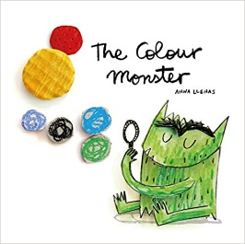 | Children can begin to talk about their own and others feelings and/or use the emotions board. | happy, sad, hungry, thirsty, excited, angry, busy, scared, confused, overwhelmed, identifying, emotions, control. | My Monster and Me  The Colour Monster Goes to School  Ruby’s Worry  Worry Monster soft toy | Children express their feelings and consider the feelings of others.  They identify and moderate their own feelings socially and emotionally.
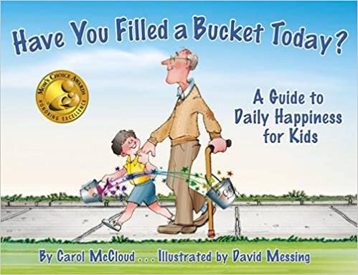 | Together, as a class, we create a bucket of golden rules agreed by all | Same, different, truthful, emotion, content, worried, sharing, helping, rule, follow, empathy, gratitude, respect, kindness, compliment, encouragement. | Mr Potato Head – a rule for each body part – can you build him together towday? | Increasingly follow rules, understanding why they are important. Remember rules without needing an adult to remind them.
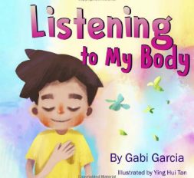 | Children can begin to understand what they can do to help their bodies to regulate. | Body parts: elbow, muscle...; 8 senses: vision, touch; feeling, emotion, express, sensations, foundation, clues, empowers, self-regulation. | Yoga. Mindfulness. | Children show resilience and perseverance in the face of challenge. They identify and moderate their own feelings socially and emotionally.
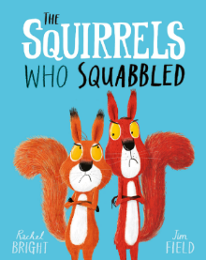 | Children can begin to understand that we all look and feel differently and this is okay. | panicked, frightened, argumentative, exhausted, brave, determined, hysterical, satisfied, frantic, rivalry, hoard, bicker, cooperation, reconciliation. | Role plays. Problem solving. Puppets. | Children see themselves as a valuable individual. They build constructive and respectful relationships and think about the perspectives of others.
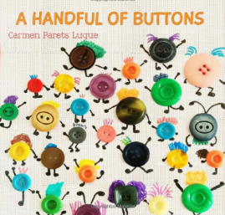 | Children can talk about themselves and their families; they become aware of diversity, recognising that we are all unique and hold special value in the world. | love, family, pets, home, school, Sennen, Cornwall, community, special, individual, unique, diversity, unity, inclusion, acceptance, equality, identity. | Chn bring in a picture of family to talk about. Anaya persona doll. | Children see themselves as a valuable individual. They can talk about members of their immediate family and community and can name and describe people who are familiar to them.
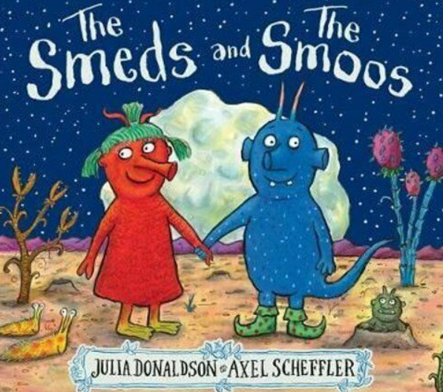 | Children appreciate similarities and differences between themselves and others. | Disgruntled, harmony, conquer, flabbergasted, triumphed. Perplexed. | Smeds and Smoos program on BBC. | Children recognise some similarities and differences between life in this country and life in other countries.  Children see themselves as a valuable individual.
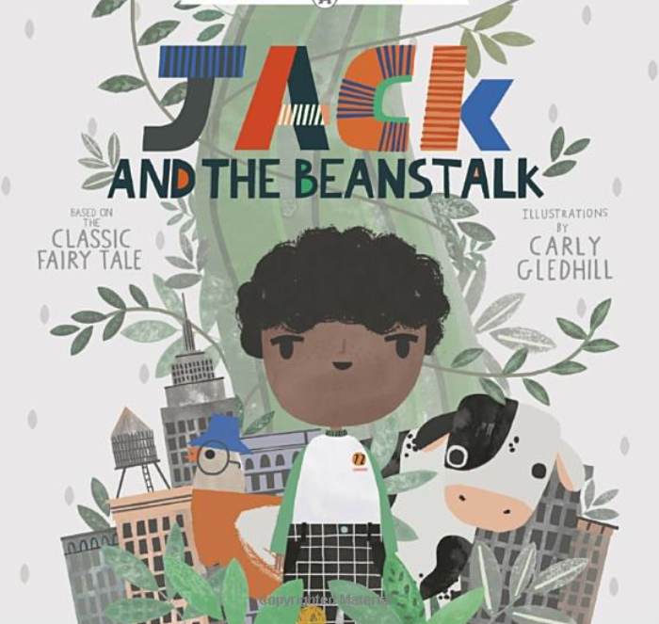 | Recognising and appreciating our own qualities; being the hero in our own story. | Astonishment, fearful, excitement, curiosity, determination, relief. | Mini me’s – make a story with me as the hero. Self portraits. | Children see themselves as a valuable individual.

