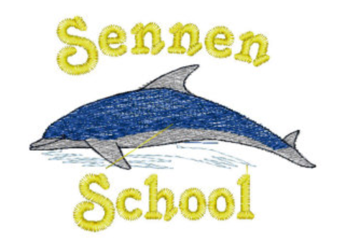
Where to go for more information
Contact the school
If you have any questions or concerns about the Prevent strategy and what it means for your child, please do not hesitate to contact the school.

See our policies
[Include links to relevant policies here]

External sources
The following sources may also be useful for further information:
Revised prevent duty guidance for England and Wales, HM Government (Adobe pdf file)
https://www.gov.uk/government/uploads/system/uploads/attachment_data/file/445977/3799_Revised_Prevent_Duty_Guidance__England_Wales_V2-Interactive.pdf
The Prevent duty: advice for schools and childcare providers, GOV.UK – DfE (Adobe pdf file)
https://www.gov.uk/government/uploads/system/uploads/attachment_data/file/439598/prevent-duty-departmental-advice-v6.pdf
What is Prevent?, Let’s Talk About It
http://www.ltai.info/what-is-prevent/

The Prevent strategy
KEY TERMS
Extremism – vocal or active opposition to fundamental British values such as democracy, the rule of law and tolerance of different faiths and beliefs
Ideology – a set of beliefs
Terrorism – an action that endangers or causes serious violence to a person/people, causes serious damage to property, or seriously interferes or disrupts an electronic system, and is intended to advance a political, religious or ideological cause
Radicalisation – the process by which a person comes to support extremism and terrorism

Frequently Asked Questions
How does Prevent relate to British values?
Schools have been required to promote British values since 2014, and this will continue to be part of the response to the Prevent strategy.
British values include:
- Democracy
- The rule of law
- Individual liberty and mutual respect
- Tolerance of different faiths and beliefs
Isn’t my child too young to learn about extremism?
The Prevent strategy is not just about discussing extremism itself, which may not be appropriate for younger children. It is also about teaching children values such as tolerance and mutual respect.
Schools should make sure any discussions are suitable for the age and maturity of the children involved.
Is extremism really a risk in our area?
Extremism can take many forms, including political, religious and ideological extremism. Some of these may be a bigger threat in our area than others.
The intention is to give children the skills to protect them from any extremist views they may encounter, now or later in their lives.
What does this mean in practice?
Different schools will carry out the Prevent duty in different ways, depending on the age of the children and the needs of the community.
Many of the things we already do in school to help children become positive, happy members of society also contribute to the Prevent strategy.
Include information about your school’s approach here, for example:
- Exploring other cultures and religions and promoting diversity
- Challenging prejudices and racist comments
- Developing critical thinking skills and a strong, positive self-identity
- Promoting the spiritual, moral, social and cultural development of pupils, as well as British values such as democracy
- Protecting children from the risk of radicalisation, such as using filters on the internet or vetting visitors who come into school
What is the Prevent strategy?
Prevent is a government strategy designed to stop people becoming terrorists or supporting terrorist or extremist causes.
The Prevent strategy covers all types of terrorism and extremism, including political and religious extremism.
How does the Prevent strategy apply to schools?
All schools (as well as other organisations) have a duty to safeguard children from radicalisation and extremism.
This means schools have a responsibility to protect children from extremist and violent views, in the same way we protect them from drugs or gang violence.
Importantly, schools can provide a safe place for pupils to discuss these issues so that they better understand how to protect themselves.

KEY TERMS
Extremism – vocal or active opposition to fundamental British values such as democracy, the rule of law and tolerance of different faiths and beliefs
Ideology – a set of beliefs
Terrorism – a violent action against people or property, designed to create fear and advance a political, religious or ideological cause
Radicalisation – the process by which a person comes to support extremism and terrorism

KEY TERMS
Extremism – vocal or active opposition to fundamental British values such as democracy, the rule of law and tolerance of different faiths and beliefs
Ideology – a set of beliefs
Terrorism – a violent action against people or property, designed to create fear and advance a political, religious or ideological cause
Radicalisation – the process by which a person comes to support extremism and terrorism

KEY TERMS
Extremism – vocal or active opposition to fundamental British values such as democracy, the rule of law and tolerance of different faiths and beliefs
Ideology – a set of beliefs
Terrorism – a violent action against people or property, designed to create fear and advance a political, religious or ideological cause
Radicalisation – the process by which a person comes to support extremism and terrorism

KEY TERMS
Extremism – vocal or active opposition to fundamental British values such as democracy, the rule of law and tolerance of different faiths and beliefs
Ideology – a set of beliefs
Terrorism – a violent action against people or property, designed to create fear and advance a political, religious or ideological cause
Radicalisation – the process by which a person comes to support extremism and terrorism

