Forest School Booklet

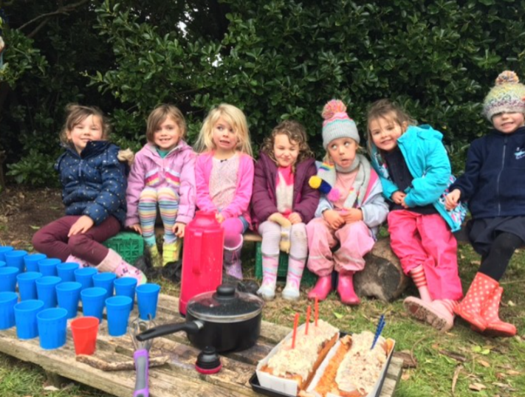

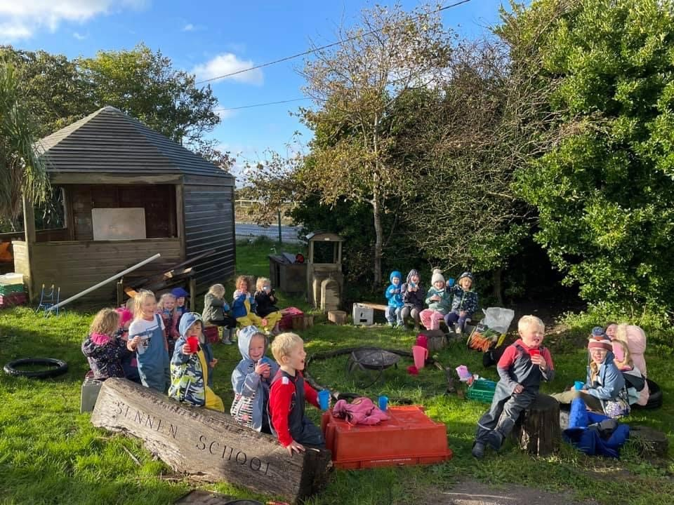

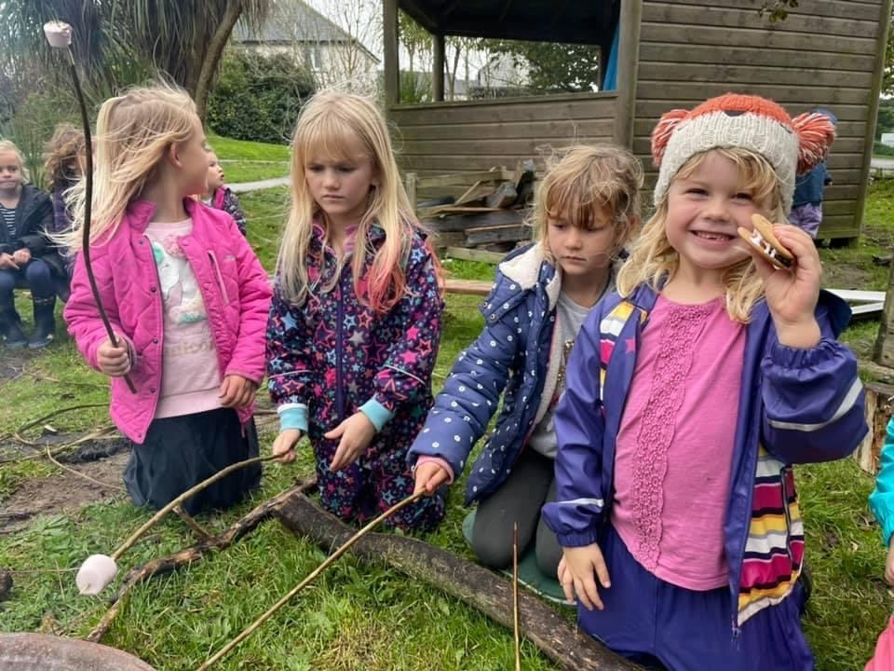

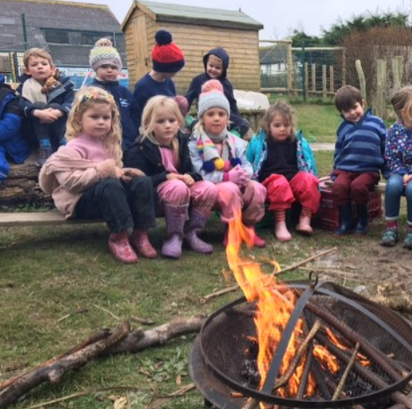
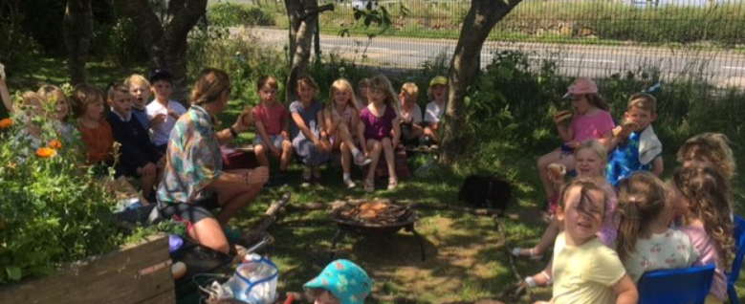
Forest School at Sennen School

Forest School Principles:
Forest School, as its name implies, is all about learning outdoors and in particular having regular access to a woodland environment over an extended period of time. But more than this, Forest School supports play-based learning that is child-led and therefore quite different to a traditional in-class approach to educating children.

Why Forest School?
Research shows that Forest School is extremely good for children: it builds self-confidence, self-esteem, resilience and wellbeing (both physical and psychological). Plus, put simply, it’s fun! All of the skills learnt at Forest School are transferable to a classroom setting so time spent at Forest School is not time wasted: it is helping children grow as happy, healthy and well-rounded individuals with a respect for and love of nature and an ability to be resilient, responsible and independent learners.

Where will Forest School be based?
We are extremely lucky at Sennen School to have wonderful green spaces with views out to sea. Some Forest School Sessions will be based on-site.
We are also very fortunate to have access to other fantastic sites within close proximity. We will also hold Forest School sessions at these sites.

What activities will be on offer during Forest School?
Forest School activities vary depending on the age, ability and preferences of the children in the session as well as the weather conditions. Here are some activities that may be included in a session:
- Den or shelter building
- Cooking over an open fire
- Bug hunts
- Woodland crafts using natural materials like wood and clay and simple tools
- Outdoor games
- Imagination play
- Storytelling

What happens during a Forest School day?

On the morning of the visit the class teacher checks the weather and decides whether the session is safe to run. Children arrive at school in their Forest School clothing. After lunch, their session will begin! This will either be on-site or off-site. In the case of an off-site session, children will take the mini-bus to the Forest School site.

Each session begins with a recap on safety rules, weather updates and an outline of activities offered.
For every session, we have a lesson plan which includes an opening task, suggested activities, snack time and a finishing activity

What equipment will be used in Forest School?
Children will have access to different tools each week, depending on what the teacher’s suggested activities are for that day. These could include:
- Den building equipment – tarps and ropes
- Magnifying glasses and ID kits
- Fire sticks
- Tools for digging – spades and garden forks
- Tools for whittling – peelers and safety knife
All activities using tools are fully risk assessed. Tools are well maintained.

Are there First Aiders on the site?
We always have first aiders with us on the day.
A First Aid kit is on site with us at every session.
Asthma pumps and any medical equipment needed will be taken to our Forest School for the duration of the session and if required this will be supervised by an adult.

If it is cold or raining will Forest School still take place?
Beach School will take part in all seasons unless we feel the weather conditions are unsafe. This decision will be made by the Headteacher as safety is paramount at all times. We will be vigilant and will be aware of weather conditions and forecast changes ahead of the visit.

What about during hot weather?

Children will need to be wearing hats and bring in sunscreen that they can reapply before we leave. We will encourage them to drink plenty of fluids and there will be frequent drinks stops throughout the afternoon. We will erect a sun shelter where necessary.

Suitable Clothing...
The children will be outside in varying weather and will need the appropriate clothing for the conditions and also possible changes of clothes. The children will need to come to school dressed in their Forest School clothes.

...for cold weather
- Hat
- Jumper/fleecs (with warm under garments – multiple layers are best)
- Warm socks (and some spare socks)
- Wellington boots
- Waterproof trousers (if you have them)
- Waterproof coat

...for hot weather
- Sun cream protection (Factor 50)
- Sun hat (preferably one that offers protection to the back of their neck)
- Sensible sturdy closed-toe shoes or wellington boots
- Preferably covered legs (no shorts)
- Spare socks
- Windproof jacket

Health and Safety:

A Health and Safety Handbook is in place for Forest Schools, this contains emergency
procedures as well as the required policies. Mrs Hulse and Mrs Smith both hold a Level 3 Forest School Leaders’ Certificate and as such are highly qualified to plan, risk assess and manage Forest School activities.

Before any session starts, staff complete a sweep of the site and also review the latest weather forecast. The Forest School leader takes medical contact details and records to site and any medication that is required on the day. These items are kept securely in the possession of the Forest School Leader. Sessions aim to equip children with the vital skills to assess and manage their own risk during Forest School.

